DRAFT
please bring this booklet to all your appointments

Surgical Optimization Patient Passport
Your pathway to surgical optimization

WHY IS THIS PASSPPORT HELPFUL?
“Surgical Optimization” or “pre-habilitation” are terms that refer to the process of improving your physical and mental condition prior to your surgery. Research has shown that surgical outcomes are not dependent on the operation alone, but also on a patient’s overall health status.
Physically and emotionally preparing for surgery can reduce your risk of complications from surgery and speed up your recovery time. This Passport, along with your Health Care Team, are important resources to help ensure that you have the best possible surgical experience and outcome.
MY CARE TEAM:

These health care professionals, family members and friends are here to support me before, during and after surgery:
 | Name | Phone Number
Family Doctor / Nurse Practitioner
Surgeon
Nurse Navigator
Anesthesiologist
Internal Medicine
Dietitian
Physiotherapist
Support Person
Other

IMPORTANT DATES:

Pre-Surgical Screening Appointment Date | Surgical Date

SURGICAL OPTIMIZATION JOURNEY
Time period to prepare yourself for surgery

ADDITIONAL NOTES FROM CARE TEAM:

NUTRITION

Preparing for surgery is like training for a race. Having surgery is stressful on your body. Good nutrition is important to help prepare your body for surgery and to help with healing afterwards. Eating a healthy diet rich in protein and with enough energy, can prevent complications. Choose a variety of healthy foods.

Protein:
- Choose 2-3 servings of meat or alternatives each day (meat, eggs, nuts, seeds, beans, tofu)
- Choose 2-3 servings of dairy products each day (milk, yogurt, cheese)

Energy:
- Eat 3-6 times per day, spread across the day
- If you have a poor appetite or have been losing weight, try:
  - eating small amounts more often
  - Include a fat source at each meal such as oil, butter, margarine, cream, sweet treat and nuts
  - Drink energy rich beverages between meals, such as milk, juice or nutritional supplement drink such as Ensure, Boost, Carnation Instant Breakfast or Glucerna
  - Avoid foods labelled “light”, “low calorie”, “Reduced Fat”, “fat-free”, “reduced sugar”. Choose full fat yogurt and cheese, whole milk
  - Have Ready-made frozen meals and prepared snacks on hand (i.e. granola bars, cheese and crackers, pudding, nuts, trail mix)

Diabetes:
- Wounds take more time to heal for people who have diabetes. You can optimize your healing by improving your blood sugar management.
- Goal for blood sugar levels should be 4-10 mmol/L.
- Goal for HgA1C (3 month average) is less than 7%

My plan to improve my nutrition before surgery is:

COMMUNITY RESOURCES

- Call 8-1-1 Dietitian services @ HealthLink BC
- Kamloops Outpatient Dietitian Services: 250-314-2740
- Kamloops Diabetes Clinic: 250-314-2457
- https://www.healthlinkbc.ca/healthy-eating
- https://food-guide.canada.ca/en/
- Diabetes Canada http://www.diabetes.ca
- Meal delivery Service: http://www.bettermeals.ca
Healthy Eating for Everyone

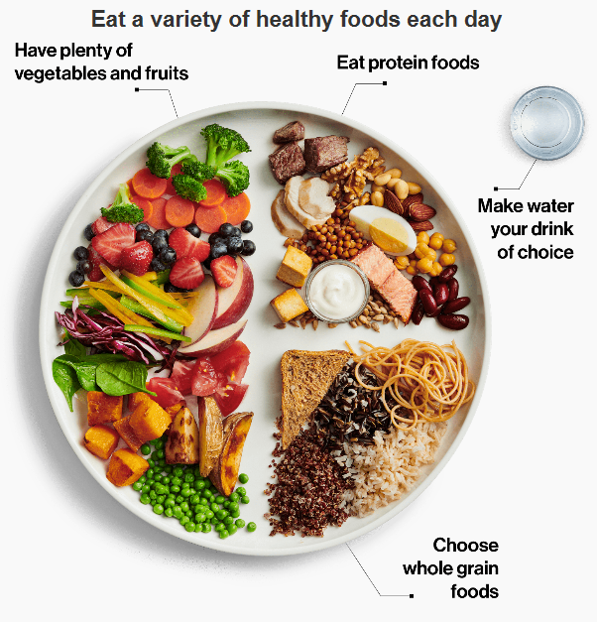

EXERCISE

You don’t have to be able to run a marathon or work out in a gym to improve your outcomes after surgery. Increasing the amount of activity you already do can improve your muscle strength, endurance, balance, and overall health. For example adding a walking program or taking a gentle exercise class can help prepare you for surgery. Exercise can also help to control high blood pressure and high blood sugars.
The Canadian Physical Activity Guidelines suggests:
- Doing 150 minutes of exercise a week in bouts of 10 minutes or more at a time
- Adding in strength exercises 2 days per week
- Working hard enough to get a light sweat or breathe harder

Right now, I do _________________ minutes of exercise a week.
I will try to do _________________ minutes of exercise a week before my surgery date.
COMMUNITY RESOURCES

Kamloops
• YMCA/YWCA—A wide variety of community based exercise programs
• Westsyde Pool and Fitness Centre
• Tournament Capital Centre (Aquatic Centre and indoor walking track)
• Private Gyms, Yoga and Pilates studios
Helpful websites
- Keep on Moving www.keeponmoving.ca
- Canadian Exercise Guidelines (www.cspeguidelines.ca)
- Type into your browser:
  - Introductory Resistance Program – Diabetes Canada
  - Resistance Exercise brochure – Diabetes Canada

SMOKING CESSATION

Smoking/ Vaping is bad for your health. What you may not realize is smokers who have surgery are twice as likely to have major complications. You can change this!
If you stop smoking before surgery and during recovery you will:
- Heal faster  - Improve your breathing  - Improve blood/oxygen flow to, and reduce stress on your heart | - Shorten your hospital stay, GET HOME SOONER!!

An effective way to quit smoking is a combination of counselling and Nicotine Replacement Therapy. Talk to your care team about the best plan to quit. This will significantly improve your chances of having a smooth recovery.
COMMUNITY RESOURCES

- Quit Now! Phone 1-877-455-2233 or Text: QUITNOW to 654321
- www.quitnow.ca/join
- Free 3 month supply of either nicotine gum or patches, or a free prescription for smoking-cessation drugs, with a Pharmacist or physician’s prescription.

ANEMIA MANAGEMENT

Low red blood cells, or hemoglobin, is called Anemia. Managing anemia prior to surgery reduces blood transfusions, hospital stays, and promotes early mobilization. Red blood cells (hemoglobin) carry oxygen and nutrients to your surgical site and are important for healing. Low red blood cells can often be improved prior to surgery.
You will have your hemoglobin and ferritin tested.

My Hemoglobin is:
Normal Hemoglobin: Men 140-160
Women 120-160

My Ferritin (iron) is:

Normal Ferritin: Men 20-500 ng/ml
Women 20-200 ng/ml

Based on my bloodwork I have been recommended to:
No treatment
Oral Iron and Vitamin C
Oral Iron: _______ mg/day
Vit. C: _______ mg/day
IV iron infusions

MENTAL WELLNESS

Anxiety or worry related to an upcoming surgery is normal. There are ways to decrease your anxiety, which can improve your surgical experience and even your recovery.
Some people do best when details and information regarding their surgery are clear to them. Do you have outstanding questions that your care team can answer? 1.___________________________________________________________________2.___________________________________________________________________
Some people do best when they have distractions to take their minds off their upcoming surgery. Some healthy distractions and coping strategies that may be helpful are:
- Deep breathing
- Relaxation methods (mindfulness, grounding & progressive muscle relaxation)
- Quiet activity: reading, puzzles, listening to music, movies, visiting with friends/family, time with pets, being outdoors, meal prep/baking, self-care
i.e. haircut, shave, bath, massage, sleep, light exercise, yoga.
- Limit the time you spend worrying
- Consider what you would say to a friend in the same situation

My healthy distractions:
1. _______________________________________________________________
2. _______________________________________________________________
COMMUNITY RESOURCES

- Kamloops Mental Health & Substance Use: 250-377-6500
Helpful Websites:
- Anxiety Canada https://anxietycanada.com/
- Canadian Mental Health: Bounce Back program https://kamloops.cmha.bc.ca/programs-services/bounce-back/
Type into your browser:
- Positive Coping with Health Conditions
ADDITIONAL CONSIDERATIONS

You may have additional factors to consider that are unique to you and your health. You and your care team will determine if there are any other tools, resources, or strategies that can help optimize your health for surgery.

Additional risks I need to consider are:

Options, tools, strategies or resources to reduce these risks are:

NOTES

You are well on your way to being physically and mentally prepared for surgery.

COMING TO THE HOSPITAL

Things to bring (please limit belongings to one small bag):
- Housecoat
- Nonslip slippers
- Toothpaste, toothbrush
- Health Carecard or BC Services Card
- Extended benefits card
Do not bring valuables or more than $20 cash. If you wish to rent a TV/telephone, you can do so with a credit card or cheque. Interior Health will NOT assume responsibility for any items that are lost or stolen.
On the day of surgery:
- Arrive on time
- Report and register at the admitting desk
- You will then be given more instructions on where to go
Surgeries can sometimes be postponed due to emergencies, bed availabiliy and your current health.
If your health changes (for example, flu, cold, diarrhea, etc) you must notify Pre-Surgical Screening or your Nurse Navigator immediately (Monday – Friday 7 am to 3 pm). Leave a message and your call will be returned.

Adapted from the Campbell River Hospital patient passport

